**Task 01:** Complete the tables with required data *40 points*

**Task 02:** Attach screenshots of the simulated circuits *40 points*

**Task 03:** What did you find from the experiment? *20 points*

**Name & ID:** Md. Rifat Ahmed ~ 1931725042

**Task 01:**

Table 01 for Fixed Biasing Circuit:

|  |  |  |  |
| --- | --- | --- | --- |
| **Transistor** | VCE | IC | Q(VCE, IC) |
| BD135 | 4.56V | 11.6mA | Q(4.56V, 11.6mA) |
| C828/ 2N2222 or 2N3904 | 2.93V | 15.0mA | Q(2.93V, 15.0mA) |

Table 2 for Voltage Divider biasing Circuit:

|  |  |  |  |
| --- | --- | --- | --- |
| **Transistor** | VCE | IC | Q(VCE, IC) |
| BD135 | 2.58V | 7.17mA | Q(2.58V, 7.17mA) |
| C828/ 2N2222 or 2N3904 | 2.56V | 7.21mA | Q(2.56V, 7.21mA) |

**Task 02:**

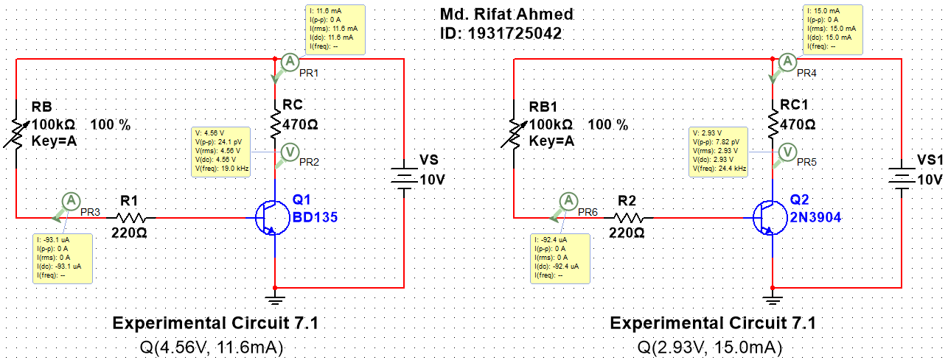

Figure 1: Fixed Bias Circuit

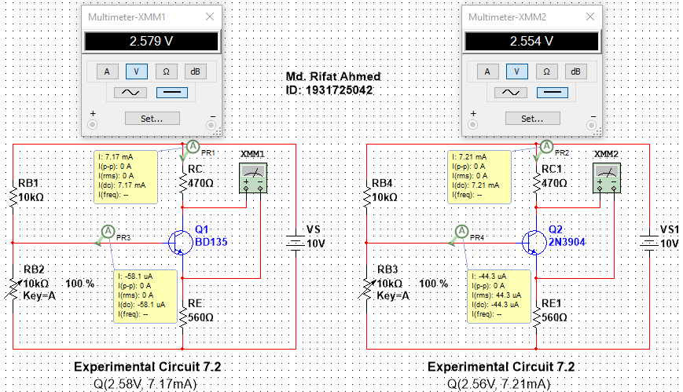

Figure 2: Self-Bias Circuit

**Task 03:**

In this experiment from the two Fixed Bias Circuit and Self Bias circuit we took the Q points for two different BJT BD135 and 2N3904. From the tables, we can see that the value of Q point for the 1st circuit is varying a lot for the two BJTs while the Q point of the 2nd circuit is almost the same. So from this experiment, we find that the self-bias circuit is showing a better stability of the Q points.